*Avoiding tradeoffs between global wild seafood production and seafloor impacts through fisheries innovation*

T. Scott Smeltz1,2, Suresh A. Sethi2,3, Bradley Harris2, Jonathan H. Grabowski4, Olaf P. Jensen5, Christopher M. Free6

1New York Cooperative Fish and Wildlife Research Unit, Department of Natural Resources, Cornell University, Ithaca, NY 14853, USA

2Alaska Pacific University, Fisheries, Aquatic Science and Technology (FAST) Laboratory, Anchorage, AK 99508, USA

3U.S. Geological Survey, New York Cooperative Fish and Wildlife Unit, Cornell University, Ithaca, NY 14853, USA.

4Department of Marine and Environmental Sciences, Marine Science Center, Northeastern University, Nahant, MA 01907, USA.

5Department of Marine and Coastal Sciences, Rutgers University, New Brunswick, NJ, 08901, USA

6Bren School of Environmental Science and Management, University of California, Santa Barbara, Santa Barbara, CA, 93106, USA.

Keywords: benthic habitat; trawl fisheries; gear modifications; maximum sustainable yield; land sparing

Abstract (max 200 words, currently 207)

Wild seafood is an important component of the global food supply, satisfying 8% of animal-based protein demands1. Trawls and other bottom-tendered fisheries dominate catches from the seafloor and can impact benthic habitats, thereby degrading marine ecosystems. Consequently, mitigating seafloor impacts is a key management consideration for sustainable fisheries. Here, we estimate global seafloor disturbance from fishing and quantify the additional habitat impacts associated with maximizing seafood production to meet growing global food demands. Currently, 8% (3.4 million km2) of the continental shelf is impacted by fishing gear, a seafloor area comparable to the land area used in terrestrial protein production. If these fisheries were managed to achieve maximum sustainable yields, global harvests could increase by 22% (9.1 million mt/year), but with a 10% increase in the seafloor area impacted (290,000 km2). Fishing modifications that reduce gear-seafloor interactions may provide a means to overcome this tradeoff. A global reduction in gear-seafloor interactions of 30%—an amount within the range of existing gear modifications—could mitigate the increase in habitat impacts associated with maximum sustainable harvests from bottom fisheries. Current progress in implementing gear modifications remains slow, emphasizing opportunities to advance technical innovations to balance food production and habitat impacts in the world’s fisheries.

Introduction

Wild harvested seafood is a key component of diets throughout the world, accounting for 8% of animal-based protein consumed globally1. Human population growth coupled with increasing per capita protein consumption is projected to increase global demand for protein by as much as 50% by 20502. Meeting this demand will require increasing production across multiple food sectors including wild capture seafood. Although commercial fisheries catches have remained relatively stable over the last several decades, recent analyses indicate that increasing global harvest may be achieved not only by improved management of overexploited stocks, but also by increasing fishing pressure on underexploited stocks3. ~~The challenge is to achieve this additional harvest while minimizing added environmental impacts.~~ Additional harvest opportunities, however, present a challenge in managing and minimizing increased environmental impacts associated with greater seafood production.

All food sectors contend with environmental tradeoffs4, and habitat conversion associated with food production systems represents a primary amplifier of climate-driven ecosystem changes and a threat to biological diversity globally5. One of the most controversial environmental costs associated with wild capture fishing is disturbance to the seafloor from fishing gear (e.g., trawls, dredges, etc. ~~(hereafter collectively referred to as trawls)~~, which together account for 41% of all wild harvested seafood6. Seafloor impacts from fishing gear include the degradation and removal of epibenthic organisms as well as the scattering of geological structural formations such as cobble piles, which provide critical refuge, spawning, and foraging grounds for marine organisms. Moreover, these impacts to benthic habitats, commonly refferred to ecosystem impacts of fishing, may threaten the sustainability of the harvested fish species that depend on them7,8.

Recent compilations of global fishing effort derived from the satellite-monitored Automatic Identification System (AIS)9 have provided a view of the global extent of fishing pressure on the seafloor. These data have been used to estimate that the total footprint of all fishing activity from 2013 - 2016 covered up to 55% of the world’s oceans9. However, there are limitations when estimating the scale of seafloor impacts from the global fishing effort footprint. First, the potential for seafloor impacts is dominated by trawls and other mobile bottom-tendered gears such as dredges, whereas pelagic fishing activity, which is also recorded by AIS, results in little or no contact with the ocean bottom and thus negligible seafloor impacts. Second, typically only specific components of a fishing gear used on or near the seafloor actually touch it, such that the seafloor area potentially impacted duringa fishing event is less than its total swept area path10. Third, the organisms and geological features that create habitat structure on the seafloor demonstrate varying degrees of susceptibility to contact and capacity to recover from damage or removal11. Thus, estimating disturbance to the seafloor – defined here as the areal extent in which benthic features have been damaged or removed by trawling and have not yet recovered to pre-trawling levels – requires a dynamic impact and recovery model that incorporates habitat specific vulnerabilities, gear characteristics, and an understanding of how gear contacts the seafloor12.

Minimizing seafloor disturbance is a high priority for many of the world’s fishery management bodies (e.g. 13,14) and a prerequisite for maintaining ocean ecosystem integrity7. To date, marine reserves have been the primary tool to meet this objective. While marine reserves have demonstrated successes15,16, especially when protecting highly vulnerable seafloor habitats, they can have limitations as a commercial fisheries management measure. In many cases, fishing effort is displaced elsewhere, such that spatial closures may not achieve success without other corresponding policies to reduce effort or total allowable catches17. But, as global demand for protein mounts with increasing human population, reducing fishery harvests as a means to control seafloor impacts may lead to a difficult tradeoff. Aside from the socioeconomic consequences of reduced harvest, there may be concomitant environmental impacts associated with producing substitute protein from other food systems, such as terrestrial crops or livestock. One means to avoid the tradeoff between benthic habitat impacts and foregone fishery harvest is to minimize seafloor disturbance by reducing gear-seafloor interactions – a direct solution that may be met through gear modifications to reduce seaflor contact from fishing, or increases in catch efficiency that maintain harvest rates but with less expended effort.

Here, we quantify seafloor impacts from fishing and explore options for navigating seafood production and environmental impact tradeoffs. We first assess the areal extent of global seafloor disturbance by trawling activities using a dynamic impact and recovery model12 and compare area-based production estimates from the ocean with habitat impacts on land from equivalent terrestrial protein production. We then use catch-based stock assessment models to evaluate the potential for sustainable harvest increases from trawl fisheries globally and within large marine ecosystems (LME) to meet growing protein demands, and estimate the increase in seafloor disturbance associated with increasing fishing pressure to achieve maximum sustainable yield (MSY) under conventional gear configurations and fishing practices. Finally, we demonstrate how innovations in fishing gear technology and/or improvements in capture efficiency may reduce the effects of trawling on the seafloor and help mitigate the impacts of fishing on seafloor habitats globally.

Results/Discussion

We used a dynamic benthic habitat impact and recovery model12 and time series of AIS-derived fishing effort data through 2018 to estimate the current scale of global seafloor disturbance (Fig. 1), finding that total global seafloor disturbance from trawling was 3.4 million km2 (8% of the world’s continental shelves). This estimate includes upward adjustments for ten LMEs which were identified as having low AIS coverage of their fleet as indicated by a anomalously low ratio between harvest and AIS-derived fishing effort as compared to well-covered LMEs. The distribution of seafloor disturbance from fishing varied widely among LMEs (Extended Table 1). Ten of the world’s 66 LMEs were estimated to have <1% of their shelf area disturbed by fishing, whereas three LMEs were estimated to have >40% disturbance (Yellow Sea, Iberian Coastal, and Celtic-Biscay Shelf). Mid- and high-latitude LMEs in the Northern hemisphere, excluding those in the Arctic, generally had higher levels of seafloor disturbance than low-latitude and Southern hemisphere LMEs. The highest concentrations of LMEs with high disturbance (>25% of shelf area) were in European waters and Eastern Asia waters. Arctic and Antarctic LMEs had relatively low levels of disturbance (<5%) with the exception of the Barents and Norwegian Seas (Arctic LMEs), which were estimated to have approximately 14% of their shelf area disturbed by fishing.

This disturbance to the seafloor associated with fishing is the environmental cost of harvesting ≈40 million mt of seafood (including both reported and reconstructed catches)6 from the world’s oceans each year by bottom trawls. Globally, this amounts to 11.9 mt of seafood harvested per km2 of seafloor disturbed, though the efficiency of this tradeoff is highly variable among LMEs (Fig. 1 inset). Recognizing that terrestrial land use for food production poses ecological consequences that differ substantially from those incurred from seafloor disturbance, comparisons of habitat impact vs. protein production tradeoffs among key animal production systems provides insight into the opportunity cost of foregone wild capture fisheries production. The edible protein yield of seafood averages about 11% of the live weight of fish caught18, resulting in an average of 1.3 Mg edible protein harvested per km2 of seafloor disturbed for bottom trawl fisheries annually. When comparing the amount of habitat impacted from these protein sources, we estimate that protein harvested from the seafloor to be more efficient than beef-sourced protein (0.41 Mg edible protein per km2, including land used for pasturing and feed crops), but less efficient than pork or poultry (each yield 11 Mg edible protein per km2, including land used for feed crops)19.

As the human population grows to a projected 10 billion people over the coming three decades20, pressure will mount to increase production across food sectors to meet protein demands21,22. Using a catch-based stock assessment model to evaluate current exploitation rates of fishing on the seafloor23, we found that over 83% of the fish stocks included in the analysis (1,716 of 2,070 stocks) are currently harvested at rates below that associated with MSY (Extended Fig. 1A). We estimate that maximum utilization of these stocks, along with rebuilding the 20% of overfished stocks, has the potential to sustainably increase fish harvest by 22% over current levels, an approximately 9.1 million mt per year harvest increase (1.0 million Mg of additional protein per year). In four LMEs, bottom trawl fisheries as a group are currently overfishing and would require reductions in effort to achieve MSY, presenting opportunities to simultaneously increase harvest in some regions while also reducing seafloor disturbance. However, increasing catches in most LMEs would require additional fishing effort (Figure 2). Aggregating across all assessed stocks, net global bottom trawl fishing effort would need to increase by 45%, adding over 8 million additional hours of fishing to the world’s oceans each year. Under an assumption that this increase in fishing effort would be distributed in proportion to past fishing effort, the cumulative additional impacts on the seafloor would be correspondingly less, increasing total seafloor disturbance by 10% (>290,000 km2, equivalent to an area the size of Italy) as fishing impacts often overlap in space with already disturbed habitat24.

While global bottom trawl fisheries have potential for higher harvests, under current fishing practices, increases in seafood from these resources will present a tradeoff between accepting additional seafloor impacts across most LMEs, or alternatively, shifting this foregone harvest to land-based food systems to meet future protein demands. For example, to supply the 1 million Mg of additional protein harvested if MSY were achieved with beef-sourced protein would require an additional 2.4 million km2 of land devoted to pasture and agricultural land for feed; pork and poultry would require 90,000 km2 of additional agricultural land for feed. However, it may be possible to avoid this impasse through innovations that allow trawl harvest to increase without incurring additional effects to the seafloor. Two approaches show promise in this regard.

First, opportunities exist to modify fishing gears to reduce seafloor contact, while still maintaining catch performance. For example, a simple gear modification of attaching small spherical lifting ‘bobbins’ to the footrope of a bottom trawl has been demonstrated to reduce seafloor contact by up to 95% without significant effect on the catch efficiency of targeted groundfish in large North Pacific fisheries10 (Fig. 3, A). In other examples, novel trawl door designs have been used to dramatically reduce bottom contact of trawl gear components25 (Fig. 3, B), and newly developed pulse trawls utilize electrical pulses to stimulate groundfish or shrimp into moving upwards for capture above the seafloor26 (Fig. 3, C). Second, policies or technologies that increase catch efficiency such that less effort is expended per unit harvest can reduce seafloor impact in attaining prescribed catches. By aligning economic incentives with long term sustainable fishing practices, dedicated access privileges-based fisheries management helps avoid wasteful fishing practices and reduces the fishing effort needed to achieve a given catch27. For instance, upon transitioning to individual harvest quota-based management, total days at sea for Nova Scotia offshore scallop decreased by 15 – 20%28. On the other hand, management approaches that reduce the efficiency of fishing - such as marine protected areas located in productive fishing grounds29- have the potential to inadvertently increase effort to achieve target catches, resulting in an increase in the area of seafloor impacted per unit of fish harvested.

Through innovative approaches to modify fishing gear or increase catch efficiency, it may be possible to significantly reduce the seafloor impact of bottom-tendered fisheries at seascape scales. Using our global dynamic impact and recovery model and aggregating across LMEs, we find that MSY harvest levels from bottom fisheries could be achieved with no net increase in aggregate seafloor impact if fleets were to employ gears with 30% less contact, increase CPUE by 33%, or combine both efforts in lesser extents (Figure 3, D). Regardless of future catch targets, innovations to reduce seafloor contact would be beneficial for reducing ocean ecosystem impacts from fishing under current harvest levels. For example, we estimate that fishing gear modifications that lead to a relatively small 10% reduction in bottom contact would lead to a global reduction of 136,000 km2 of seafloor disturbance, whereas a 50% reduction in contact—within the limits of existing successful gear modification experiments—would spare 782,000 km2 of seafloor disturbance across the world's continental shelves.

While the rising cost of land has driven dramatic land use efficiency improvements in terrestrial-based animal protein systems over the last half century30, fisheries innovations have progressed at a slower pace. Impediments to fisheries innovations are both economic and regulatory; however, solutions to catalyze progress in many fisheries are already available. The costs to research and implement new fishing technologies can be high, especially for undercapitalized fisheries, but growing activity in conservation finance31 may provide capital to accelerate technological advances. Similarly, fisheries governance reforms that align economic incentives with reductions in seafloor impacts through individual habitat quotas may spur gear and fishing practice innovations among fishers32.

Acknowledgements

This work was funded by the Atkinson Center Academic Venture Fund, and the Alaska Education Tax Credit funds of the Groundfish Forum and the Pollock Conservation Cooperative. We thank D. Kroodmsa and T. Clavelle of Global Fish Watch for supplying AIS fishing data. We are grateful to R. Murphy, D. Verna, and A. Kroska for comments that improved this piece.

Author contributions

T. S. S., S. S., B. H., and O.J. conceived of the project. T.S.S. conducted the seafloor disturbance analyses. C.F. conducted the catch-only stock assessment analyses. All authors contributed to the writing.

Methods

Seafloor disturbance model

Seafloor disturbance was estimated using a spatiotemporal model that incorporates impact and recovery dynamics to track the proportion of disturbed and undisturbed areas within grid cells over discrete time steps. The full model is detailed in 12. We used a 2 km x 2 km grid over monthly time steps for these analyses, limiting the domain to the world’s continental shelves, defined here as depths from 0 m - 1,000 m. Impacts are defined as the proportional amount of undisturbed seafloor within a grid cell that transitions to a disturbed state over a time step. Disturbances are calculated for each grid cell and time step as the product of the total swept area ratio (SAR), gear contact adjustment, and habitat susceptibility, which is then adjusted to account for overlapping effort on the assumption that fishing effort is randomly distributed within a grid cell and time step. The SAR is the summed footprint of all trawl activity within the grid cell and time step; contact adjustment is the proportion of the footprint that contacts the seafloor; susceptibility is the proportion of habitat features that would be disturbed by contact. In the main text, contact adjustment is referred to in terms of contact reduction for ease of interpretation, where contact reduction is the complement of contact adjustment ($contact reduction=1-contact adjustment$). Recovery is the proportional amount of disturbed seafloor that transitions back to an undisturbed state and is parametrized in this analysis by the mean time required for seafloor habitats to recover from to 5% to 95% of their pre-disturbance levels (Supplementary Methods). The susceptibility and recovery parameters are based on the seafloor habitat type within a grid cell (from a global benthic habitat database described below).

Fishing effort and gear parameters

Fishing effort data was provided by Global Fish Watch (<https://globalfishingwatch.org/>) which they compiled from AIS data using a neural network to identify vessel type and behavior (e.g., fishing or transiting)9. We acquired the data as daily hours fished by gear type on a 0.01-degree grid for 2013 – 2018. Our seafloor impact analyses included only effort designated as trawlers and other mobile bottom-tendered gears. The effort data was aggregated to an equidistant 2 km x 2 km raster grid on monthly time steps. Fishing hours in each grid cell and time step were converted to SAR as: $SAR=\left(fishing hours\right)x\left(speed\right)x\left(gear width\right)/(grid area)$. Gear towing speeds were set a 7.408 km hr-1 (4 knots), following the average speed used to detect trawler fishing activity in the AIS data9. Gear width was set to 200 m for all effort, a conservative impact estimate at the global scale, corresponding to the upper range of trawl widths 33. ~~The grid area was 4 km~~~~2~~ ~~(2 km x 2 km).~~

Susceptibility and recovery of seafloor habitats

The recovery rate and susceptibility of seafloor habitats was based on the habitat type of each grid cell. Global maps of seafloor habitats were downloaded from <https://www.nceas.ucsb.edu/globalmarine2008/ecosystems> (see 34 for a description of these datasets). The downloaded maps were resampled to the 2 km x 2 km grid and aggregated into three broad habitat categories (soft substrate, hard substrate, and rocky reef) to align with habitat categories employed by the habitat vulnerability meta-analysis used to parameterize recovery 11,35,36. We generally employed conservative estimates of susceptibility and recovery parameters, using the slowest recovery rates reported by these meta-analyses: 9.6 years for soft substrates, 9.1 years for hard substrates, and 25.3 years for rocky reefs. Susceptibility was set to 0.3 for all habitat types following the findings of 11. Additional detail on benthic recovery rate sources and standardization efforts is provided in the Supplementary Methods. ~~See the Supplemental Methods for further details about the methodology used to extract consistent recovery rates from these disparate analyses.~~

Model runs

Three types of model runs were used in these analyses: 1) initial condition burn-in, 2) baseline model runs, and 3) forward projection scenarios. To create reasonable initial conditions of seafloor disturbance for the start of the baseline model, we first conducted a “burn-in” model run. This entailed setting seafloor disturbance to 0% for all grid cells domain-wide for the initial conditions of the burn-in and randomly selecting and applying effort levels from all available years of fishing effort data for each respective month (e.g., for each January in the burn-in, a random January realization of effort was selected from 2013-2018). This burn-in was run for 30 years to allow ample time for seafloor disturbance to equilibrate under effort levels representative of current fishing levels.

Next, the baseline model was run using the final month results of the burn-in as its initial conditions. The baseline model was run using monthly fishing effort data in consecutive order from 2013 - 2018. Results presented in the main text reflect the estimates for December 2018, the terminal month of the fishing effort data. Based on discussions with the data providers, some LMEs, particularly at lower latitudes, were known to have low AIS coverage of their bottom-tendered fisheries. We identified ten LMEs as likely to have low AIS coverage of their bottom-tendered gear fleets by identifying LMEs that were univariate outliers in their ratio of 2014 total harvest to fishing effort (Extended Fig. 4, A). We upward adjusted estimated seafloor disturbance for these LMEs using k-means clustering to group all LMEs into ten catch groups based on their harvest profiles (proportional harvest of functional groups). For each catch group, we used a linear model relating logit-transformed seafloor disturbance (%) to logged total harvest (mt year-1) using the remaining LMEs with high AIS coverage. Adjusted estimates for the low coverage LMEs were then estimated from these models. Within the low AIS coverage LMEs, the resulting adjustments approximately doubled estimated seafloor disturbance. At the global scale, this increased estimated seafloor disturbance from 2.9 million km2 (unadjusted estimated) to 3.4 million km2 (adjusted estimate, reported in main text), a 13% increase. These effort-adjusted LMEs were excluded from subsequent harvest and contact adjustment scenario analyses.

Four forward projection scenarios were conducted: 1) business-as-usual (BAU) fishing effort, 2) MSY fishing effort, 3) BAU fishing effort with contact reduction, and 4) MSY fishing effort with contact reduction. The terminal month of the baseline model was used as initial conditions for all forward projection model runs. For each run of the forward projection scenarios, fishing effort for each month was randomly selected from all available years (same process as the random selection for the initial condition burn-in). In the BAU scenario, we drew directly from the realized fishing data. The MSY scenario adjusted the realized fishing data with an LME-specific parameter representing the ratio of estimated fishing effort at MSY to baseline fishing effort ($E_{msy}/E_{base}$). The contact adjustment scenarios used realized fishing effort, but adjusted impacts over a range of contact reductions (0%, 10%, 20%, 30%, 40%, and 50%). The MSY fishing with contact reduction was a combination of the two scenarios. These forward projections were each run for 30 years, using the mean of the last 15 years as reported values. Uncertainty in these estimates was calculated from the standard error of these means, and reflect the variability in year-to-year fishing effort intensity and spatial distribution of fishing effort. All reported estimates of relative change in seafloor disturbance for the MSY, contact reduction, and MSY/contact reduction scenarios are relative to the BAU scenario.

MSY forward projection scenarios

Running the MSY scenarios required estimation of the $E_{msy}/E_{base}$ ratio for each LME as well estimating fishery yield at MSY. This required first estimating the exploitation rate, $U$, and standing biomass, $B$, for trawl caught stocks both at MSY ($U_{msy}, B_{msy}$) and baseline levels ($U_{base}, B_{base}$). We estimated these parameters using Robin-Hood cMSY23, an adaptation of the catch-MSY catch-only stock assessment method37,38, to assess marine fish and invertebrate stocks in the Sea Around Us Database6. We defined stocks as LME and species combinations and evaluated the 2,198 stocks with at least 20 years of reported catch data and more than 1,000 mt of maximum reported catch, which captured 54.6% of global reconstructed catch.

Robin-Hood cMSY (RH-cMSY) is based on the cMSY38 stock reduction analysis but uses information from data-rich stocks to set priors for data-poor stock parameters. In general, both methods reconstruct historical abundance and exploitation rates by simulating biomass trajectories that could feasibly produce the observed catch time series given assumptions about initial and final year depletion and population parameters such as carrying capacity, *K* and intrinsic growth rate, *r*. RH-cMSY primarily differs from cMSY in that it uses meta-analyses of data-rich stocks in the RAM Legacy Stock Assessment Database39 to set priors for all four values. Furthermore, it uses a Pella-Tomlinson rather than a Schaefer surplus production model to account for asymmetry in production40 and does not use the “tip of the triangle” assumption employed in cMSY.

Yield for each stock in the MSY scenarios was calculated from the $U_{msy}$ and $B_{msy}$ parameters estimated in the RH-cMSY analysis as: $Y_{msy}=U_{msy}B_{msy}$. Yield for the LME was the sum of the yield from all stocks within the LME. However, this only reflects the data- rich stocks included in the RH-cMSY analysis, thus the percent change in yield at MSY over baseline conditions presented in the main text reflects only these stocks. Estimations of total yield at MSY (mt year -1) presented in the main text apply this percent change to the total LME-wide baseline yield.

Estimating $E_{msy}/E_{base}$ began from the basic fishery equation relating yield, effort, stock biomass, and catchability, $q$: $Y=qEB$. Solving for $E$ then gives the ratio as follows:

|  |  |  |
| --- | --- | --- |
|  | $$\frac{E_{msy}}{E_{base}}=(\frac{Y_{msy}}{q_{msy}B_{msy}})(\frac{q_{base}B_{base}}{Y_{base}})$$ | (1) |

In order to estimate this ratio, a relationship between catchability at MSY and baseline conditions is needed. As a simplifying assumption, we assumed that catchability at MSY is equal to that at baseline conditions ($q_{msy}=q_{base}$), reducing eq. (1) to:

|  |  |  |
| --- | --- | --- |
|  | $$\frac{E_{msy}}{E_{base}}=(\frac{Y_{msy}}{B_{msy}})(\frac{B_{base}}{Y_{base}})$$ | (2) |

Additionally, because $E_{msy}/E_{base}$ is used at the level of the LME, the yields and stock biomasses in eq. (2) reflect the sum of these values across an LME for stocks included in the RH-cMSY analysis.

References

1. FAO. *The state of world fisheries and agriculture 2018 - meeting the sustainable development goals*. (2018).

2. Alexandratos, N. & Bruinsma, J. *World agriculture towards 2030/2050: the 2012 revision*. *ESA Working paper No. 12-03* (2012). doi:10.1002/jso.2930300113

3. Hilborn, R. & Costello, C. The potential for blue growth in marine fish yield , profit and abundance of fish in the ocean. *Mar. Policy* **87**, 350–355 (2018).

4. Hilborn, R., Banobi, J., Hall, S. J., Pucylowski, T. & Walsworth, T. E. The environmental cost of animal source foods. *Front. Ecol. Environ.* **16**, 329–335 (2018).

5. Newbold, T. *et al.* Global effects of land use on local terrestrial biodiversity. *Nature* **520**, 45–50 (2015).

6. Pauly, D. & Zeller, D. Sea Around Us Concepts, Design and Data. (2015). Available at: seaaroundus.org. (Accessed: 15th September 2019)

7. Watling, L. & Norse, E. A. Disturbance of the seabed by mobile fishing gear: a comparison to forest clearcutting. *Conserv. Biol.* **12**, 1180–1197 (1998).

8. Pikitch, E. K. *et al.* Ecosystem-based fishery management. *Science (80-. ).* **305**, 346–347 (2004).

9. Kroodsma, D. A. *et al.* Tracking the global footprint of fisheries. *Science (80-. ).* **359**, 904–908 (2018).

10. Rose, C. S., Gauvin, J. R. & Hammond, C. F. Effective herding of flatfish by cables with minimal seafloor contact. *Fish. Bull.* **108**, 136–144 (2010).

11. Grabowski, J. H. *et al.* Assessing the vulnerability of marine benthos to fishing gear impacts. *Rev. Fish. Sci. Aquac.* **22**, 142–155 (2014).

12. Smeltz, T. S., Harris, B. P., Olson, J. & Sethi, S. A. A seascape scale habitat model to support management of fishing impacts on benthic ecosystems. *Can. J. Fish. Aquat. Sci.* (2019).

13. *Magnuson- Stevens Act Provisions; Essential Fish Habitat (EFH). 50 CFR part 600. U.S. Federal Register, vol.67*. 2343–2383 (2002).

14. *Directive 2008/56/EC of the European Parliament and of the Council of 17 June 2008 establishing a framework for community action in the field of marine environmental policy (Marine Strategy Framework Directive)*. (2008).

15. Edgar, G. J. *et al.* Global conservation outcomes depend on marine protected areas with five key features. *Nature* **506**, 216–20 (2014).

16. Lester, S. E. *et al.* Biological effects within no-take marine reserves: A global synthesis. *Mar. Ecol. Prog. Ser.* **384**, 33–46 (2009).

17. Greenstreet, S. P. R., Fraser, H. M. & Piet, G. J. Using MPAs to address regional-scale ecological objectives in the North Sea: Modelling the effects of fishing effort displacement. *ICES J. Mar. Sci.* **66**, 90–100 (2009).

18. Torry Research Station Aberdeen (UK). Yield and nutritional value of the commercially more important fish species. *FAO Fisheries Technical Paper. No. 309* 187 (1989).

19. Herrero, M. *et al.* Livestock and the Environment: What Have We Learned in the Past Decade? *Ssrn* (2015). doi:10.1146/annurev-environ-031113-093503

20. United Nations Department of Economic and Social Affairs Population Division. *World population prospects 2019*. *Department of Economic and Social Affairs. World Population Prospects 2019.* (2019).

21. Halpern, B. S. *et al.* Putting all foods on the same table: Achieving sustainable food systems requires full accounting. *Proc. Natl. Acad. Sci. U. S. A.* **116**, 18152–18156 (2019).

22. Costello, C., Cao, L. & Gelcich, S. *The future of food from the sea*. (2019).

23. Free, C. No Title.

24. Smeltz, T. S., Harris, B., Olson, J. & Sethi, S. A. A seascape scale habitat model to support management of fishing impacts on benthic ecosystems. *Can. J. Fish. Aquat. Sci.* **9**, 1–9 (2019).

25. McHugh, M. J., Broadhurst, M. K., Sterling, D. J. & Millar, R. B. Relative benthic disturbances of conventional and novel otter boards and ground gears. *Fish. Sci.* (2019). doi:10.1007/s12562-019-01392-2

26. He, P. & Winger, P. D. Effect of Trawling on the Seabed and Mitigation Measures to Reduce Impact. in *Behavior of Marine Fishes: Capture Processes and Conservation Challenges.* (ed. He, P.) 295–314 (Wiley-Blackwell, 2010).

27. Essington, T. E. *et al.* Catch shares, fisheries, and ecological stewardship: A comparative analysis of resource responses to a rights-based policy instrument. *Conserv. Lett.* **5**, 186–195 (2012).

28. Brander & Burke. Rights-based vs. competitive fishing of sea scallops.

29. Hilborn, R. *et al.* When can marine reserves improve fisheries management? *Ocean Coast. Manag.* **47**, 197–205 (2004).

30. van Zanten, H. H. E., Mollenhorst, H., Klootwijk, C. W., van Middelaar, C. E. & de Boer, I. J. M. Global food supply: land use efficiency of livestock systems. *Int. J. Life Cycle Assess.* **21**, 747–758 (2016).

31. Fitzgerald, T. P., Higgins, P. R., Quilligan, E., Sethi, S. A. & Tobin‐de la Puente, J. Catalyzing fisheries conservation investment. *Front. Ecol. Environ.* 1–8 (2020). doi:10.1002/fee.2147

32. Holland, D. & Schnier, K. E. Individual habitat quotas for fisheries. *J. Environ. Econ. Manage.* **51**, 72–92 (2006).

33. Amoroso, R. O. *et al.* Bottom trawl fishing footprints on the world’s continental shelves. *Proc. Natl. Acad. Sci.* **115**, 201802379 (2018).

34. Halpern, B. S. *et al.* A global map of human impact on marine ecosystems. *Science (80-. ).* **319**, 948–52 (2008).

35. Hiddink, J. G. *et al.* Global analysis of depletion and recovery of seabed biota after bottom trawling disturbance. *Proc. Natl. Acad. Sci.* **114**, 8301–8306 (2017).

36. Graham, N. A. J., Nash, K. L. & Kool, J. T. Coral reef recovery dynamics in a changing world. *Coral Reefs* **30**, 283–294 (2011).

37. Martell, S. & Froese, R. A simple method for estimating MSY from catch and resilience. *Fish Fish.* **14**, 504–514 (2013).

38. Froese, R., Demirel, N., Coro, G., Kleisner, K. M. & Winker, H. Estimating fi sheries reference points from catch and resilience. 506–526 (2017). doi:10.1111/faf.12190

39. Ricard, D., Minto, C., Jensen, O. P. & Baum, J. K. Examining the knowledge base and status of commercially exploited marine species with the RAM Legacy Stock Assessment Database. *Fish Fish.* **13**, 380–398 (2012).

40. Thorson, J. T., Branch, T. A. & Jensen, O. P. Using model-based inference to evaluate global fisheries status from landings , location , and life history data. *Can. J. Fish. Aquat. Sci.* **69**, 645–655 (2012).

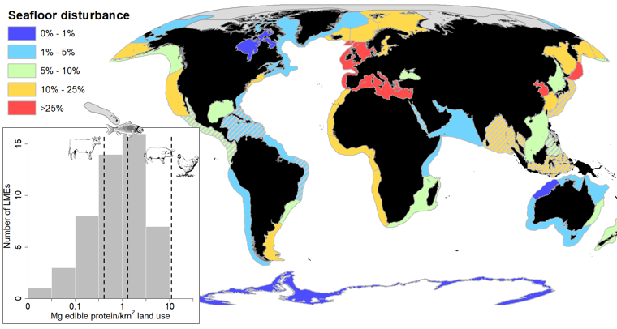

Figure 1. Seafloor disturbance (% of continental shelf area) throughout the world’s Large Marine Ecosystems (LMEs). Hashed areas show LMEs with low AIS coverage for which fishing effort was estimated using an upward adjustment procedure. The inset figure shows habitat-use efficiency (Mg edible protein produced per km2 of disturbed habitat) on log10 scale associated with bottom-tendered fisheries for the world’s LMEs. Dashed vertical lines show the global mean habitat use efficiency for fishing across LMEs, as well as mean reported values for beef production (generally less efficient) and pork and poultry production (more efficient).

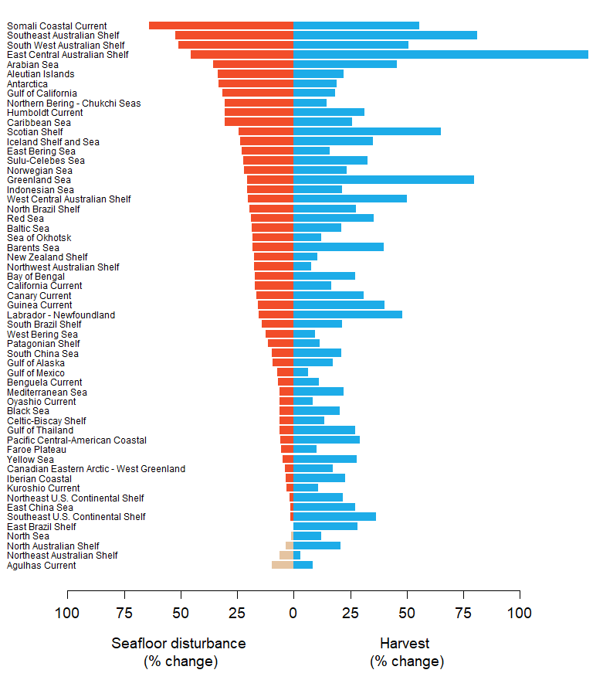

Figure 2. Tradeoffs between increased bottom-tendered fishery harvest and seafloor disturbance among the world’s Large Marine Ecosystems (LMEs). Increases in LMEs seafloor disturbance depend on both the amount of effort needed to achieve maximum sustainable yields (MSY) and the spatial distribution of effort, where more concentrated fishing effort can lead to incrementally lower increases in areas impacted relative to regions with more diffusely spread effort. Blue bars show the percent increase in yearly harvest at MSY fishing over current harvest level. Red bars show the estimated percent increase in seafloor disturbance over current levels. Tan bars indicate a percent reduction in seafloor disturbance for four LMEs currently fishing above MSY in which case reducing fishing effort would lead to both increased harvest and reduced habitat impacts.

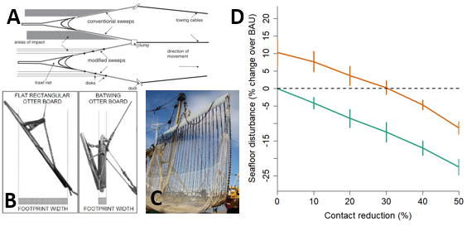

Figure 3. Gear modifications and their effect on global seafloor disturbance. Panels A, B, and C show examples of recently developed gear modifications that reduce seafloor contact. Panel A is a drawing of a groundfish trawl equipped with conventional sweeps compared to one outfitted with bobbins. Panel B shows a conventional trawl door compared to a modified (“batwing”) trawl door. Panel C shows a pulse trawl which uses electrical pulses instead of direct contact with the seafloor to stimulate fish. Panel D shows estimated change in global seafloor disturbance (% change over current) ~~business-as-usual (BAU)~~) under a range of contact reduction scenarios; zero contact reduction indicates seafloor disturbance under current fishing practices. The green line shows the seafloor disturbance scenarios under current fishing levels in which global trawl harvest remains stable relative to 2013-2018 harvest rates, whereas the orange line indicates disturbance scenarios under global bottom-tendered fishing associated with maximum sustainable yields. Vertical bars give two standard errors reflecting year-to-year variability in simulated fishing effort.

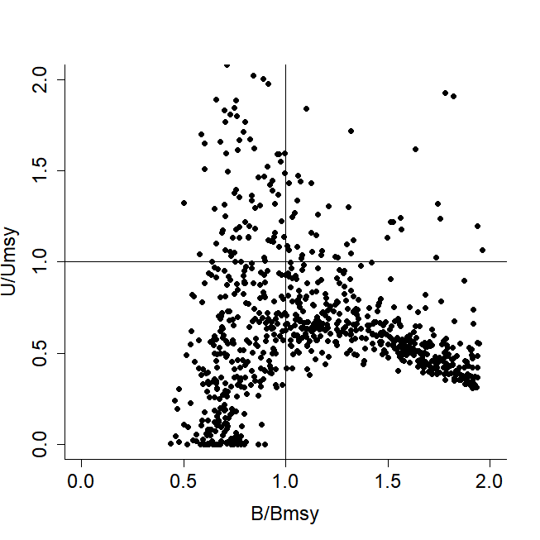

Extended Figure 1. ~~Kobe plot showing the~~ Status of global bottom-tendered gear fisheries showing exploitation rate and stock biomass relative to MSY of stocks estimated using the RH-cMSY catch-only assessment model. The vertical axis is the ratio of current exploitation rate to that at MSY ($U/U_{MSY}$). The horizontal axis is the ratio of current stock biomass to that at MSY ($B/B_{MSY}$).

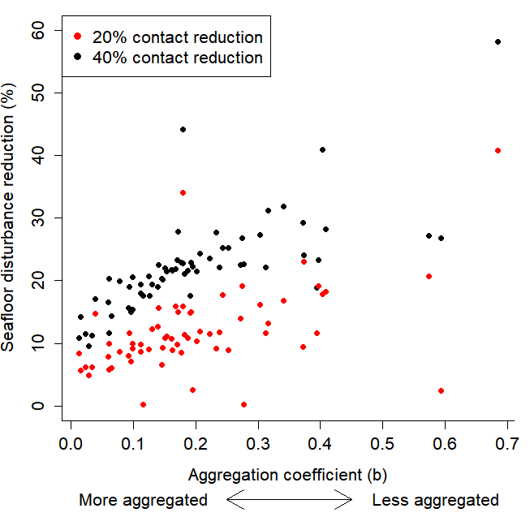

Extended Figure 2. Effect of fishing effort aggregation on effectiveness of contact reduction. The vertical axis is the estimated reduction in seafloor disturbance for LMEs for 20% (red points) and 40% (black points) contact reduction scenarios. The horizontal axis is an aggregation coefficient ($b$, see Supplemental Methods for a description of this parameter), where higher values of $b$ represent less spatially aggregated fishing effort. The positive correlation of level of effort aggregation and reduction in seafloor disturbance suggest that contact reduction may be more effective when fishing effort is less aggregated and more diffusely distributed throughout an LME.

Extended Table 1. Seafloor disturbance, harvests, and estimated maximum sustainable yields for bottom-tendered fisheries by large marine ecosystem (LME).

| **LME** | **Seafloor disturbance (%)** | **Shelf area (sq. km)** | **Aggregation coefficient (b)** | **2014 trawl harvest (1,000 mt)** | $$E_{msy}/E_{last}$$ | $$Y_{msy}/Y_{last}$$ |
| --- | --- | --- | --- | --- | --- | --- |
| Agulhas Current | 7.2 | 470,184 | 0.14 | 108.9 | 0.87 | 1.25 |
| Aleutian Islands | 6.8 | 83,264 | 0.18 | 508.1 | 1.85 | 1.13 |
| Antarctic | 0.2 | 2,721,116 | 0.19 | 146.7 | 1.85 | 1.08 |
| Arabian Sea | 1.9 | 861,776 | 0.17 | 584.5 | 2.28 | 1.42 |
| Baltic Sea | 20.2 | 377,548 | 0.11 | 436.4 | 1.77 | 1.42 |
| Barents Sea | 14.3 | 1,793,564 | 0.15 | 229.3 | 1.55 | 1.67 |
| Bay of Bengal | 0.5 (15.5)a | 897,204 | 0.1 | 2,072.5 | 1.89 | 1.27 |
| Beaufort Sea | 0.1 | 620,780 | 0.59 | 0 | - | - |
| Benguela Current | 17.1 | 400,664 | 0.13 | 1,095.2 | 1.25 | 1.27 |
| Black Sea | 5.8 | 190,820 | 0.06 | 355.9 | 1.3 | 1.46 |
| California Current | 10.9 | 206,296 | 0.11 | 407.3 | 1.55 | 1.21 |
| Canadian Eastern Arctic -West Greenland | 3.6 | 1,004,632 | 0.12 | 141.8 | 1.1 | 1.25 |
| Canadian High Arctic - North Greenland | 0 | 372,060 | -b | 0 | - | - |
| Canary Current | 22.9 | 269,340 | 0.09 | 3,229.3 | 1.71 | 1.24 |
| Caribbean Sea | 0 (2.5) | 850,176 | 0.39 | 33.8 | 1.41 | 1.55 |
| Celtic-Biscay Shelf | 45.9 | 591,924 | 0.06 | 1,109.8 | 1.41 | 1.25 |
| East-Central Australian Shelf | 5.7 | 87,520 | 0.15 | 5.1 | 3.46 | 4.47 |
| East Bering Sea | 14.3 | 633,352 | 0.22 | 735.9 | 1.59 | 1.12 |
| East Brazil Shelf | 0.2 (4.2) | 200,136 | 0.28 | 38.7 | 1.59 | 1.27 |
| East China Sea | 20.2 | 682,420 | 0.02 | 3,489.5 | 1.43 | 1.29 |
| East Siberian Sea | 0 | 612,960 | 0.68 | 0 | - | - |
| Faroe Plateau | 34.1 | 87,984 | 0.1 | 287.3 | 1.24 | 0.92 |
| Greenland Sea | 3.1 | 561,164 | 0.08 | 77.1 | 1.74 | 1.92 |
| Guinea Current | 17.8 | 377,376 | 0.1 | 1,624.7 | 1.95 | 1.44 |
| Gulf of Alaska | 8.9 | 441,872 | 0.17 | 565.0 | 1.29 | 1.19 |
| Gulf of California | 0.3 (7.1) | 125,020 | 0.18 | 160.5 | 1.74 | 1.16 |
| Gulf of Mexico | 5.5 | 726,084 | 0.19 | 566.3 | 1.18 | 1.08 |
| Gulf of Thailand | 0.8 (14) | 381,072 | 0.04 | 1,163.6 | 1.4 | 1.31 |
| Hudson Bay Complex | 0.2 | 1,234,880 | 0.19 | 0.5 | - | - |
| Humboldt Current | 2.8 | 403,220 | 0.18 | 139.0 | 1.73 | 1.83 |
| Iberian Coastal | 44.5 | 88,436 | 0.03 | 86.3 | 1.3 | 1.51 |
| Iceland Shelf and Sea | 24.9 | 286,752 | 0.16 | 575.6 | 1.95 | 1.9 |
| Indonesian Sea | 0.1 (13.2) | 1,136,496 | 0.13 | 968.5 | 1.69 | 1.18 |
| Insular Pacific-Hawaiian | 0.1 | 52,192 | 0.37 | 0 | - | - |
| Kara Sea | 0.4 | 923,308 | 0.3 | 0 | - | - |
| Kuroshio Current | 6.9 (12.3) | 227,912 | 0.27 | 782.3 | 1.08 | 1.33 |
| Laptev Sea | 0.1 | 818,764 | 0.57 | 0 | - | - |
| Mediterranean Sea | 25.7 | 1,035,708 | 0.03 | 461.9 | 1.46 | 1.3 |
| New Zealand Shelf | 7.5 | 546,724 | 0.21 | 278.4 | 1.43 | 1.15 |
| Newfoundland-Labrador Shelf | 4.4 | 868,248 | 0.19 | 253.2 | 1.29 | 1.86 |
| North Australian Shelf | 1.5 | 771,604 | 0.27 | 22.9 | 1.13 | 1.26 |
| North Brazil Shelf | 1.4 | 519,492 | 0.06 | 94.0 | 1.69 | 1.43 |
| North Sea | 37.8 | 667,836 | 0.06 | 1,572.5 | 0.94 | 1.1 |
| Northeast Australian Shelf-Great Barrier Reef | 1.6 | 496,736 | 0.14 | 6.3 | 0.98 | 1.23 |
| Northeast U.S. Continental Shelf | 11.8 | 307,664 | 0.18 | 561.9 | 1.23 | 1.38 |
| Northern Bering - Chukchi Seas | 2.2 | 1,159,852 | 0.37 | 240.3 | 1.68 | 1.16 |
| Northwest Australian Shelf | 0.9 | 508,748 | 0.31 | 10.3 | 1.31 | 1.3 |
| Norwegian Sea | 14.4 | 217,312 | 0.16 | 218.8 | 1.68 | 1.45 |
| Oyashio Current | 25.9 | 101,540 | 0.09 | 663.9 | 1.1 | 1.12 |
| Pacific Central-American Coastal | 0 (8.2) | 298,504 | 0.12 | 246.2 | 0.96 | 1.14 |
| Patagonian Shelf | 14.6 | 1,137,476 | 0.15 | 848.9 | 1.35 | 1.17 |
| Red Sea | 0 (4.5) | 387,040 | 0.32 | 47.5 | 1.85 | 1.61 |
| Scotian Shelf | 2.1 | 277,256 | 0.25 | 49.0 | 1.51 | 2.05 |
| Sea of Japan / East Sea | 9.3 | 369,320 | 0.15 | 1,454.1 | NA | NA |
| Sea of Okhotsk | 14.5 | 1,063,660 | 0.2 | 3,418.0 | 1.49 | 1.35 |
| Somali Coastal Current | 1.4 | 136,572 | 0.23 | 87.4 | 2.59 | 1.48 |
| South Brazil Shelf | 8.2 | 347,128 | 0.24 | 74.8 | 1.38 | 1.23 |
| South China Sea | 6.6 | 1,727,392 | 0.01 | 5,149.6 | 1.52 | 1.18 |
| Southeast Australian Shelf | 1.3 | 239,984 | 0.34 | 6.1 | 2.48 | 3.64 |
| Southeast U.S. Continental Shelf | 1.9 | 297,204 | 0.17 | 38.8 | 1.21 | 1.48 |
| Southwest Australian Shelf | 1.3 | 347,704 | 0.41 | 6.0 | 1.81 | 2.28 |
| Sulu-Celebes Sea | 0 (7.9) | 346,416 | 0.4 | 217.9 | 2.02 | 1.34 |
| West-Central Australian Shelf | 2.1 | 167,408 | 0.4 | 2.7 | 1.63 | 2.06 |
| West Bering Sea | 24 | 154,720 | 0.24 | 438.9 | 1.22 | 1.04 |
| Yellow Sea | 41.1 | 430,080 | 0.02 | 2,055.6 | 1.74 | 1.22 |
| Central Arctic | 0 | 22,772 | - | 0 | - | - |

a Numbers given in parentheses indicate adjusted estimates of seafloor disturbance due to low AIS coverage

b Dashes (-) indicate insufficient data to calculate